RESUME 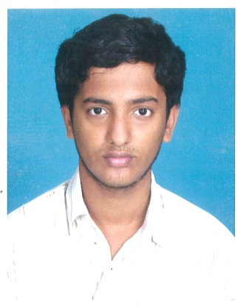
YOUSUFF PARVEZ.
No: 5/3 Mohammed Hussain Khan Lane,
Dr. Besant Road, Ice House,
Chennai – 600 014.
Mobile : 9840491954/9940209206.
Resi : 044- 28472988.
Email :YousuffParvez@gmail.com

CAREER OBJECTIVES
To chalk out a career which quenches my thirst for learning and strive always to create better, safer and faster practices in whatever I do and contribute positively to business and society as a whole.
EDUCATIONAL QUALIFICATION
QUALIFICATION | SCHOOL/COLLEGE | YEAR OF Joining | PERCENTAGE OF MARKS
M.B.A. | Mohamed Sathak College Of Arts And Science | 2011-2013 | -
B.Com | The New College, Royapettah  Chennai – 600 014. | 2006-2009 | 45%
Higher Secondary | Private | 2006 | 45%
S.S.L.C. | Private. | 2004 | 50%

EXPERTISE
- Microsoft Word
- Microsoft Excel
- Microsoft Power Point
- All Asia Intra Bournvita quiz contest Secured Second Class
- Tally 9.0.
- Advanced Diploma in Java Progamming(ADJP).
- Madras Management Association Memebership(MMA).
- Nen Member(National Enterpreneurship Network).
- Oracle Database 10g Introduction to SQL Finished Course and now iam doing PL/SQL course now.
LANGAUAGES KNOWN
To Read, Write & speak : Tamil, English and French
To Speak : urdu Hindi.

PERSONAL DATA
Name : Yousuff Parvez.
Father’s Name : Md. Basheeruddin.
Date of Birth : 24.02.1989.
Nationality : Indian.
Religion : Muslim.
Marital Status : Single.
Sex : Male.
Mother Tongue : Urdu.
Leisure Pursuit : Listening music, Reading Books and Chatting.

DECLARATION
I hereby declare that all the information given above is true to the best of my knowledge.

Date : Yours Faithfully
Place : Chennai
(YOUSUFF PARVEZ)

