ARINDAM CHAKRABORTY
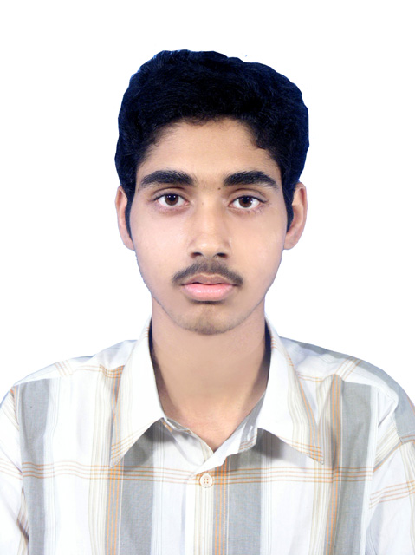
Personal Vitae

Address : c/o-Malay Chakraborty
Vill- Jogikhope
P.O- Kakgechia
Dist- Purba Medinipur
Pin-721649
WB, India

Contact No : +91-9126343826

E-Mail : arindamchakraborty1990@gmail.com

Career Objective

Seeking a position to utilize my skills and abilities in the Core Industry that offers professional growth
while being resourceful, innovative and flexible.

Educational Credential
___________________________________________________________________________________________

Completed B.Tech in ELECTRONICS & COMMUNICATION ENGINEERING from Bengal Institute of Technology & Management, Santiniketan under West Bengal University of Technology.

Year  Of  Passing | Qualification | Stream | University/Board | College/  School | Grade
2012 | B.Tech | Electronics & communication Engineering  [ECE] | West Bengal University of Technology | Bengal  Institute of Technology & Management, Santiniketan | Semester | Point
 |  |  |  |  | 1 | 6.67
 |  |  |  |  | 2 | 7.19
 |  |  |  |  | 3 | 7.07
 |  |  |  |  | 4 | 7.20
 |  |  |  |  | 5 | 7.15
 |  |  |  |  | 6 | 7.72
 |  |  |  |  | 7 | 7.74
 |  |  |  |  | 8 | 8.00
 |  |  |  |  | CGPA | 7.41
2008 | Higher Secondary | Science | WBCHSE | Kakgechia High School | 67.40%
2006 | Secondary | General | WBBSE | Hamilton High School | 79.50%

- Subjects of Interest:
- Basic knowledge of Networking .
- Basic knowledge of Telecommunication .

- Computer Proficiency:

- Knowledge of ‘C’ programming language.
- Basic knowledge of Core Java.

Key Projects
Project Type | Duration | Institution/Organization | Project/Training title
Summer Training | 04-07-2011 to  16-07-2011 | Netaji Subhash Chandra Bose Telecom Training Centre , Kalyani, Nadia (West Bengal) | Training on communication from BSNL

Final Year Project | Cell Phone Detector
EXPERIENCE:
Company name | Designation | Duration
Exl Infotel | Site Engineer | 20th February2013 To 10th june2013
Alcacell solutions | RF. Engineer | 16th Septembor2013 To onwards
- Extra Curriculum Activities:
- Learn Painting from Pracheen Kala Kendra.

- Personal Dossier:
- Father’s Name- Mr. Malay Chakraborty.
- Date of Birth- 13th July 1990.
- Blood Group- O+
- Marital Status- Single.
- Language known- English, Hindi, Bengali.
- Nationality- Indian.
- Hobbies- Net surfing, Playing cricket, Listening to music.

- Declaration:
I hereby declare that the information furnished above is true to the best of my knowledge.

Place: Kolkata, West Bengal, India _____________________
Date: Arindam Chakraborty

