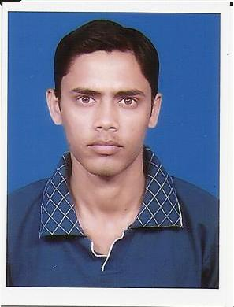
CURRICULUM VITAE’

ARIJIT PAUL
C/O – SURAJIT PAUL

Qrt. No. 29/94, Ashoke Avenue, A-Zone,

Post+P.S. - Durgapur, Pin Code-713204,

Dist - Burdwan, West Bengal.
Contact No – 09800765492

OBJECTIVE:-
To build a career with leading corporate with committed and dedicated people which will help me to explore myself fully and realize my potential. Willing to work as a team player and lead wherever necessary.

EDUCATIONAL QUALIFICATION:-

NAME OF EXAMINATION | BOARD /  UNIVERSITY | YEAR OF PASSING | % OF MARKS
Madhyamik | W.B.B.S.E | 2005 | 56.88%
Higher Secondary | W.B.C.H.S.E | 2007 | 46.00%
B.A(ECO) | APPEAR

COMPUTER SKILLS:-
- Advance Diploma in Computer Hardware Maintenance & Networking.
- Certificate Course in Web Page Designing. (Photoshop, Flash, HTML)
- Diploma in Mechanical Maintenance Fitter.

WORK EXPERENCE:-
- Computer repair & Maintenance in a shop / Police workshop (CPVF) (4 year).

PERSONAL PROFILE:-

NAME : ARIJIT PAUL
DATE OF BIRTH : 27th Feb, 1988
ADDRESS : Qrt. No- 29/94, Ashoke Avenue, A-Zone,
Post+P.S – Durgapur, Dist-Burdwan (W.B)
CONTACT NO : 9800765492
CO-CURRICULAR
ACTIVITIES : NSS
SEX : Male
NATIONALITY : Indian
RELIGION : Hindu
MARITAL STATUS : Unmarried
HOBBY : Listening Song
LANGUAGES KNOWN : Bengali, Hindi & English

DECLARATION: -

I hereby declare that the information furnished above is true to the best of my knowledge.

DATE :
PLACE: SIGNATURE

