Curriculum Vitaé

Name : Soumit Das
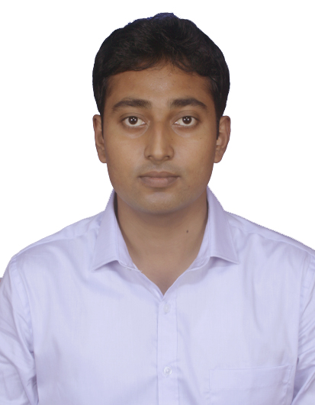
Please affix a
Passport size
photo here
Address : 3rd Lane, Farm Side Road,
P.O.: Chinsurah R.S., P.S.: Chinsurah,
Hooghly, Pincode- 712102, West Bengal
Mobile No : 09432926470

E-mail : soumit.ece@gmail.com

soumitdas@ymail.com

Career Objective:
To make an entry level opportunity in the some technology where I can make a positive impact in my field of activity, leading to organizational and personal growth by creative application of value based convictions, job skills and professional dexterity.

Academic Qualifications:

Degree / Certificate | Qualification | Institute | Board /  University | Year | Aggregate % / CGPA
Graduation | B.Tech  (Electronics and Communication Engineering) | Aansol Engineering College | WBUT | 2009-2013 | 6.88
12th | Higher Secondary | Hooghly Jyotish Chandra Vidyapith, West Bengal | WBCHSE | 2009 | 66.71
10th | Secondary | Mahesh Sri Ramkrishna Ashram Vidyalaya | WBBSE | 2007 | 71.87

Trainings Undertaken:

Name of Institute / Organization | Training On | Duration
SOUTH EASTERN RAILWAY | Signaling and Communication | 27/06/2011  TO  09/07/2011
N.S.C.BOSE TELECOM TRAINING CENTRE  BSNL | Communication | 09/01/2012  TO  21/01/2012
EASTERN RAILWAY | Exchange Systems and Networking | 25/06/2012  To  04/07/12

Academic Projects:

The project undertaken was “Infrared Ray Motion Detector”.

Additional Achievements / Certifications:

- Certification Course from NIIT in “Diploma in Java Technologies”.
- Preparing for OCJP.
- Winner of Intra-college volleyball tournament.
- Participated in Inter College Online Tech-Fest “TELOS 2012” at mywbut.com.

Key Skills:
- Computer languages: C, SQL, Java
- Knowledge of Oracle Database 10g
- Good Knowledge of Networking and Data Communication
- Proficiency in MS-Office : MS-Word, Powerpoint, MS-Excel

Hobbies:

- Bike Riding
- Cooking
- Badminton and Chess
- Listening to music and singing.
- Surfing Net.

Personal Details:

Date of Birth :17 May, 1990
Gender : Male
Languages Known :English, Hindi, Bengali

Declaration:

I, hereby, solemnly declare that all the information made above are true and correct to the best of my knowledge and belief.

Date: 18 April, 2014

Place: Kolkata

Soumit Das

