***BIO-DATA***

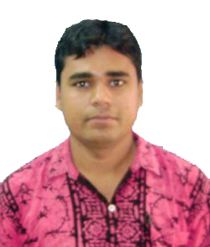NAME : SK BULBUL SAROWAR

**FATHER’S NAME :** SK ABDUL ROUF

**DATE OF BIRTH : 04/01/1988**

**CONTACT NO :** 9647219926

**PRESENT ADDRESS:** Vill+P.O-KESHPUR

P.S-KESHPUR, Dist-Paschim Medinipur

Pin-721150

**NATIONALITY :**INDIAN

**SEX :** MALE

**RELIGION :** ISLAM

**CATEGORY** **:** GENERAL

**EADUCATION QUALIFICATION:- B.A**

**EXTRA QUALIFICATION : DIPLOMA IN COMPUTER APPLICATION**

**WORKING EXPERIENCE : 5 YEARS WORKS OWN SAHAJ THATYA MITRA KENDRA**

*I here by declare that all statements/enclosed documents submitted by me are true and correct the best of my knowledge and belief.*