Resume

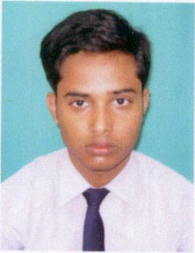
Sukamal Goswami

E-Mail:- Date of birth:-15/07/1990
- Sukamal98@gmail.com
Mobile: - 9933002015

Personal Details

Name : - Sukamal Goswami
Father’s Name : - Biltu Goswami
Mother’s Name : - Sandhya Goswami
Village : - Khidirpur
Post Office : - Khidirpur
Police Station : - Balurghat
District : - Dakshin Dinajpur
State : - West Bengal
Pin Code : - 733103
Nationality : - Indian
Religion : - Hindu
Caste : - General
Marital Status : - Unmarried

Communication Skill

- English : - Read , Write & Speak
- Hindi : - Read & Speak
- Bengali : - Read, Write & Speak (Mother Tongue).

Qualification

  - Madhyamik Examination from “W.B.B.S.E” in 2007 (Sub:- Bengali-I,II, English, Mathematics, Physical Science, Life Science, History, Geography) (Total-450, 56.25%).
  - Higher Secondary Examination from ‘W.B.C.H.S.E’ in 2009 (Sub:- Bengali,English,Philosophy,History,Sanskrit,Computer Application Total-249, 49.8%).
  - BCA completed on december 2013 from Punjab Technical University .

Additional Qualification

- Advanced Diploma in Information Technology Application (Adita) From Department of Sports & Youth Services, Government of West Bengal.

- Microsoft Office Specialist (MOS)

- Financial Accounting Program Tally.ERP9

Acknowledgement

I hereby declare that the above particulars are best of my knowledge & beliefs.

Date: - 19/06/2014
Place: - Balurghat

