**CURRICULUM ViTaE**

**SHANAKAR DAYAL MEHER**

**(B.Sc. Computer Sc. Hons)**

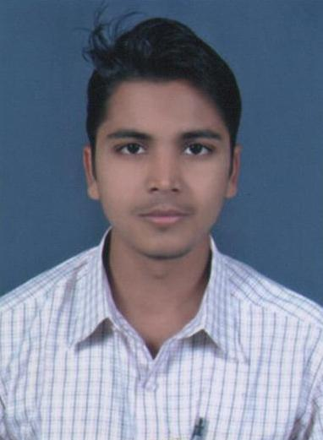***************************************************************

C/O-Kunjabihari Meher

AT/PO- Kanak Tora

VIA- Panch Gaon

DIST- Jharsuguda

PIN-768226 (Odisha).

Mobile: **+917894573945 / +919124145560**

E-mail: [hishankar_4u@yahoo.com](mailto:hishankar_4u@yahoo.com)

***************************************************************

OBJECTIVE:-

Intend to build a career with leading corporate of high-tech environment with committed and dedicate people, which will help me to explore myself fully and realize my potential, and make business more meaningful and productive , willing to work as a key player in challenging and creative environment.

EDUCATIONAL QUALIFICATION:-

**Graduation from G.M. College (Auto.) in Computer Sc. Hons.**

SEMESTER 1:-

* Digital Circuit and Computer Organization.
* Logic gates, Number System, Computer System Architecture.
* Practical based on digital circuit.
* **Semester performance : Aggregate Percentage = 77.66% Hons Percentage= 82%**

SEMISTER 2:-

* Operating System.(DOS,UNIX)
* Microsoft Office.
* Uses of Desktop Component.
* Practical based on DOS, UNIX, Microsoft Word, Excel.
* **Semester performance : Aggregate Percentage = 72.66% Hons Percentage= 89%**

SEMISTER 3:-

* Computer Architecture and Microprocessor, Achitechture of 8085, 8086, Assembly Language Programming.
* Practical based of 8085 programing, design presentation by using MS Power Point, MS_Access.
* **Semester performance : Aggregate Percentage = 79.33% Hons Percentage= 85%**

SEMISTER 4:-

* Programming in C and Data Structure(operators, selection ,loop ,array, pointer, structure, file)
* Link list-stack, queue , searching, sorting
* Practical based on C-programming, Internet.
* **Semester performance : Aggregate Percentage =82.33% Hons Percentage= 88%**

SEMISTER 5:-

* File Organization and Database Management System.(DBMS,RDBMS)
* Data Model(ER, EER Model), DML, DCL, DDL Commands.
* Object Oriented Programming using C++(class , object, inheritance, polymorphism)
* Practical based on SQL and C++ Programming.
* **Semester performance : Aggregate Percentage =74% Hons Percentage= 79%**

SEMISTER 6 :-

* + Data Communication and Computer Network(modulation, data encoding, decoding, LAN,MAN,WAN)
  + Object Oriented Programming using JAVA.
  + Computer Graphics.
* **Semester performance : Aggregate Percentage =74% Hons Percentage= 82%**

**( Over all graduation Aggregate Percentage =76% Hons Percentage= 83% )**

**Senior School Certificate Examination (+2 science) passed out form JAWAHAR NAVODAYA VIDYALAYA, Jharsuguda in 2010 :-**

* Subject combination -(Math,Physics,Chemistry,Comp. Sc.)
* Performance : Total Mark=500 , Obtained Mark=394, Percentage=78.88%

**Secondary school examination(10th) passed out from JAWAHAR NAVODAYA VIDYALAYA Jharsuguda in 2008**.

* Performance : Total Mark=500 , Obtained Mark=432, Percentage=86.44%

PROFESSIONAL QUALIFICATION :-

* **Pursuing DOT NET (C#.NET) : from NIIT**
* Object oriented programming using C#
* GUI Application Development Using .NET Framework.
* SQL Server 2005.
* Developing Database application using ADO.NET.
* Developing Web Page Designing using ASP.NET .
* **Project Work :**
* **Calculator Application Using GUI.NET Framework.**
* **Text Pad Application Using GUI.NET Framework.**
* **Computer shop management system using GUI and ADO.NET**

EXPERIENCE:-

* **Working as a faculty in DOEACC Computer Centre**.(5-08-2013 to 10-11-2013).
* **Working as Associate of Vedanta Aluminium Ltd**. Jharsuguda.(14-11-2013 to till)

ACHIEVEMENTS :-

* Achievements of **GOLD MEDAL** in BSc Comp. Science.
* Participate in **National Science Congress** in Bhopal (Madhya Pradesh).
* Participate in **National Science Conference** on Astronomical Physics.

PERSONAL PROFILE :-

Name : Shankar Dayal Meher

Date Of Birth : 8th – December -1992.

Father’s Name : Kunjabihari Meher

Gender : Male

Marital Status : Single

Language Known : English, Hindi, Odiya

DECLARATION

I, Shakar Dayal Meher S/O – Kunjabihari Meher hereby declare that the information given in the curriculum vitae is true as per my best of knowledge and belief.

Date:

Place: (Shankar Dayal Meher)