Cover Letter

Name : NARAYAN SAHA 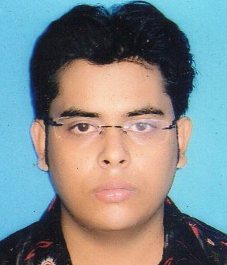
E-mail : narayan3saha@gmail.com
Contact No. : 7278783873

I am Narayan Saha, I have come to know about the job opening in your organization and I got the freedom to learn more about this field after completing my graduation from West Bengal University of Technology.

I understand that working for your organization requires a candidate who is team oriented and is able to deal with people in various departments. I am confident that I possess these skills, which will help me to perform the job efficiently and effectively.

My goal is to transit my enthusiasm, creativity and experience into a position, where I continue to provide the strategic and tactical leadership critical to retaining valued customers of an organization. I am certain that my presence in your team will prove to be beneficial to your organization. As such, I would welcome an opportunity to speak with you to evaluate your needs and share my ideas.

About my qualification B.Tech and I have scored 79.9% class in my academics. In addition to that I have enclosed my resume with this cover letter that describes about my experience and educational background related to my field.

I would be thankful if I get a chance to prove my skills and interest in your organization. I hope to work with your organization as a dedicated employee. That’s why I believe that whatever services I offer to you firm will be of great benefit to your firm.

Find my resume in the attachment for your overview. I hope for positive reply.

Sincerely,

NARAYAN SAHA
Gender : MALE
Age : 22
E-mail ID : narayan3saha@gmail.com
Contact No. : 7278783873
Address : 165D NAYAPATTY ROAD, DUM DUM, KOLKATA-700055

Academic Qualification
Year | Degree/Certificate | Institute | Board | Percentage  obtained
2014 | B.Tech | Regent Education & Research Foundation | WBUT | 79.9
2010 | Higher Secondary | Calcutta Airport English High School | WBCHSE | 68.86
2008 | Secondary | Shyamnagar High School | WBBSE | 84
Technical Plat Form
Software  platform | Operating system | WINDOWS 7
Software  platform | Languages | C, JAVA

Courses & Training
Final Year Project | Enhancing Encryption & Decryption using DES Algorithm
 | Completed Course on Core JAVA from CMC LTD

Hobbies and Interest
Hobbies | Playing Cricket, Table Tennis
Interest | Net Surfing, Electronic Gadgets.
Other Relevant Information

Father’s Name | MR. BALARAM SAHA
Language Known | ENGLISH, HINDI, BENGALI
Date of Birth | 03/11/1991
Marital Status | Not Applicable
Currently Residing at | 165D NAYAPATTY ROAD, DUM DUM, KOLKATA-700055

Declaration
I here by declare that information given above is correct to the best of my knowledge and if found incorrect the company reserves rights to cancel my Appointment∙

Date : 10.08.2014 (NARAYAN SAHA)

