Curriculum Vitaé
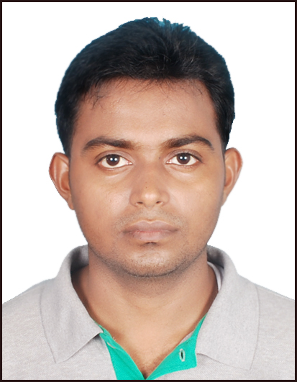

Please affix a
Passport size
photo here

Name : PERVEZ ALAM
Address : 2A BALAK DUTTA LANE KOLKATA - 700007
Mobile No : +919831231384

E-mail : pervezalam19@gmail.com

Career Objective:

I would like to be a part of an organization where I could use and enhance my knowledge and talent for the development of both the organization and myself.

Academic Qualifications:

Degree / Certificate | Qualification | Institute | Board / University | Year  of passing | Aggregate % / CGPA
Graduation | B. Tech  (Computer Science and Engineering) | Regent Education and  Research Foundation | West Bengal University  of Technology | 2010-2014 | 8.21/10
12th | Higher Secondary | Gyan Bharati Vidyapith | West Bengal Council  of  Higher Secondary Education | 2008 | 59.285%
10th | Madhyamik | SreeVisuddhananda Saraswati Vidyalaya | West Bengal Board  of Secondary Education | 2006 | 59.5%

* Aggregate Marks mean Summation of the marks obtained in all the subjects (including optional subjects) divided by the total number of subjects.
Summer Trainings / Projects Undertaken:
Name of Institute / Organization | Project Title | Duration
CMC LTD | Student Management System Based on ASP.NET using C#  Front end :Microsoft Visual studio 2013  Back end : SQL Management Server | 72 Hours

Final year project:
Project Name | Team Size | Project Description | Designing Part | Programming Language
Key Based Secret Sharing With Various Types of Secret Data | 3 | Our Project is Mainly Based on Visual Cryptography.It has a two level encryption:  (i) with Fibonacci encoding and  (ii) with ANDing-ORing technique | MATLAB 2013b | MATLAB 2013b

Computer / I T Proficiency:

- Microsoft office Word , Microsoft office Excel , Microsoft office Power Point
- Language :- C, Java

Co – Extra – Curricular Activity:
- School captain in the year 2006

Achievements:
- Won a Cup in Relay race in the year 2006
- Participated and get prizes in Quiz and Drawing competition at school level

Interest and Hobbies:
- Playing and watching Cricket, Playing Carrom, Chess, Computer game and listening Music etc.
Interpersonal Skill:
- Ability to rapidly build relationship and set up trust
- Confident and Determined
- Ability to cope up with different situations

Personal Details:
Father’s Name : MD. HANIF
Mother’s Name : ZARINA BEGUM
Date of Birth : 21.03.1990
Gender : MALE
Languages Known : ENGLISH, HINDI & BENGALI
Marital Status : SINGLE
Nationality : INDIAN
Religion : MUSLIM

Declaration:
I do hereby declare that the above information is true to the best of my knowledge.

Place:
Date : Signature

