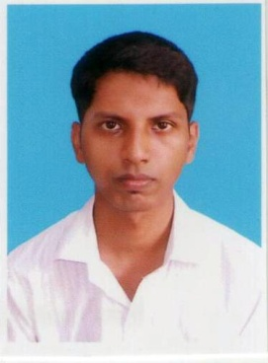**CURRICULUM VITAE**

**FIROJ RAHAMAN**

MOBILE NO**: 9874718691**

E- MAIL ID:**firoj786rahaman20111988@gmail.com**

|  |
| --- |
| PERSONAL DETAILS: |

FATHERS NAME: MUJIBAR RAHAMAN

ADDRESS: SAHAGANJ GARIB ALAM BAG

P.O-SAHAGANJ, DIST- HOOGHLY

P.S –CHINSURAH, PIN- 712104, STATE- W.B

DATE OF BIRTH: 20/11/1988

MARITAL STATUS: SINGLE

RELIGION: ISLAM

SEX: MALE

LANGUAGE KNOWN: BENGALI ENGLISH HINDI

EXPECTED SALARY: NEGOTIABLE

|  |
| --- |
| ACADEMIC QUALIFICATION |

|  |  |  |  |
| --- | --- | --- | --- |
| EXAMINATION | BOARD/UNIVERSITY | YEAR OF PASSING | DIVISION |
| MADHYAMIK | W.B.B.S.E | 2005 | 1ST |
| H.S | W.B.C.H.S.E | 2007 | 2ND |
| B.COM(H) | BURDWAN | 2010 | 2ND |

|  |
| --- |
| COMPUTER KNOWLEDGE |

**PROFICIENCY IN HANDLING OF MS-WORD, MS-EXCEL,TALLY 9.0,INTERNET,E-MAIL**

**DIPLOMA IN FINANCIAL ACCOUNTING**

|  |
| --- |
| CAREER OBJECTIVE |

Ambitious to build a career with an organization where hard working is required and appreciated and to be in a position which is best suited to my knowledge and skill.

Date: Firoj Rahaman