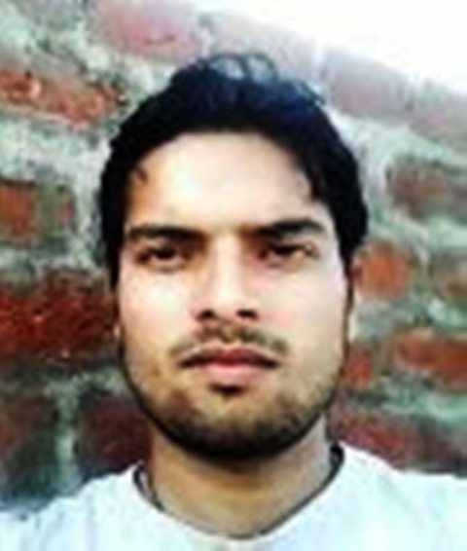

**RESUME**

SWARNENDU SHEKHAR NAYAK

Vill- Sukdal, Post- Budbud, Dist- Burdwan,

State- West Bengal, Pin- 713403

Email ID- [swarnendushekharnayak@gmail.com](mailto:swarnendushekharnayak@gmail.com)

Phone No- 8116651513.

**Career Objective :**

* To pursue a challenging career in a progressive environment where learning, innovation and creativity are encouraged, where my skills & knowledge can be enhanced to their maximum potential to contribute to the overall success and growth of the organization

**My Self :**

I am a person with positive attitude, self-confidence, quick learner, who works whole-heartedly in each and every activity taken up and thereby achieves excellence. I consider myself to be a work-oriented person having assets of intellectual knowledge, sociability and a flavor to do work in any atmosphere.

EDUCATIONAL BACKGROUND :

|  |  |  |  |  |
| --- | --- | --- | --- | --- |
| DEGREE | YEAR | INSTITUTE | BOARD/UNIVERSITY | PERCENTAGE(%) |
| Matriculation | 2007 | Budbud Mahakali  High School, Budbud | West Bengal Board of Secondary Education | 81.5 % |
| Higher Secondary | 2009 | Mankar High School,  Mankar | West Bengal Council of Higher Secondary Examination | 56.6 % |
| B.SC | 2014-running | Durgapur Govt. College,  Durgapur | Netaji Shubhas Open University | appeared |

Technical Skills :

|  |  |
| --- | --- |
| **Technology** | **Tools** |
| Database | Foxpro,MS Office(word, Excel, Access, Powerpoint),DOS, Photoshop,Visual Basic, Data Structure |
| Programming Languages | C , C++ , JAVA |
| Web Technology | HTML |
| Operating Systems | M.S. Windows 2000/XP/Vista, Windows 7, Windows 8 |
| Any Other | Analog & Digital Electronics, Certified Chip level Repairing in Computer |

Certification & Training :

* Govt. of India Certified’ Diploma in Information Technology Application ’ in Computer (Session- April,2009-March-2010 with A grade.)
* ISO 9001 : 2008 Certified‘ Diploma in Computer Teachers Training ‘ (Session- Feb,2012- May,2013 with A grade)
* GT Certified Computer Hardware & Chip level Repairing Professional.
* Govt. Certificate of type writing @ 30 w.p.m.

Area of interest :

* Database Management System.
* Object Oriented Programming Concepts.
* Hardware Repairing & Maintenance.

Extra-curricular activities :

* Master Degree completed in Tabla Playing (experience-6years).
* Participated in several cultural activities( like Fine Art ) at school level.

Languages known :

* BENGALI read, write, speak
* ENGLISH read, write, speak
* HINDI read, write, speak

Work Experience :

* NSDC Computer Faculty teacher at GT EDUCARE INDIA PVT. LTD Computer Centre at Burdwan from 6th January 2014 to 30th June 2014.

Personal details :

* Date of birth : 25 April, 1992
* Father’s name : Madhu Sudan Nayak
* Gender : Male
* Caste : General
* Religion : Hindu
* Nationality : Indian
* Marital status : Unmarried
* Hobbies : Internet surfing, Music Playing, Gardening, Learning new things.

Declaration :

I do hereby declare that all the above mention information’s furnished by me is true & correct to the best of my knowledge & belief.

Place :…………………………………..

Date :…………………………………… (Signature)