**BIO-DATA**

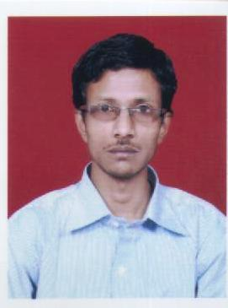

**BASUDEV ROY CHOWDHURY**

**8768674581 / 9046536079**

**PERSONAL DETAILS**

Father’s Name : DIPAK ROY CHOWDHURY

Date of Birth : 11/11/1982

Address : Nilkuthidanga, Near Raja Bandh,

Purulia - 723101

Mobile No. : 8768674581 / 9046536079

e-Mail ID : [basudevroychowdhury@gmail.com](mailto:basudevroychowdhury@gmail.com)

Nationality : Indian

Religion : Hinduism

Caste : General

Sex : Male

Marital Status : Single

**QUALIFICATION DETAILS**

Educational Qualifications :

|  |  |  |  |  |
| --- | --- | --- | --- | --- |
| Examination | Year | Board | Division | % |
| Madhyamik | 2000 | W.B.B.S.E. | 2nd | 49.00 |
| H.S. | 2002 | W.B.C.H.S.E. | ‘P’ | 38.50 |
| B.A. | 2006 | B.U. | ‘P’ | 32.00 |
| M.S.W. | App. | NSOU | App. | App. |

**OTHER QUALIFICATION**

|  |  |  |  |
| --- | --- | --- | --- |
| **Examination Passed** | **Mane of Board / Institute / University** | **Year** | **Division / Class** |
| Diploma in Bio-Chemic Medical in Surgery | C.C.B & C.H.M with Research in India | 2005 | 2nd |
| Advanced Physiotherapy Technician | W.B.S.C.T.E. | 2007 | Pass |

Computer Knowledge : CITA in Computer (Running)

**EXPERIENCE DETAILS**

Experience : Polio Camp in the year of 2002-2003 & 2003-2004

At J. K. College, Purulia

District Trainer in ASHA Programme (NRHM)

Field Researcher in Adolescent Child (UNICEF-

New concept Information Systems Pvt. Ltd.)

Currently : L.I.C. Advisor in Purulia Branch

Hobby : 1. Listening ‘Rabindra Sangit’ & Adhunik

Songs.

2. Story writing.

**D E C L A R A T I O N**

**I** hereby declare that all the particulars are written above are true to the best of my knowledge and belief.

**Date: …………………….**

**_____________________________________**

**Place: ……………………** (**BASUDEV ROY CHOWDHURY)**