Steps for Appearing In Online Examination:

Step 1: Go To https://www.worldrelation.com/Job/Home.aspx

Step 2: When online exam started you can see a list named “ONLINE EXAM STARTED”. Find your examid in the list and click it to attended the exam.(See Figure:1)

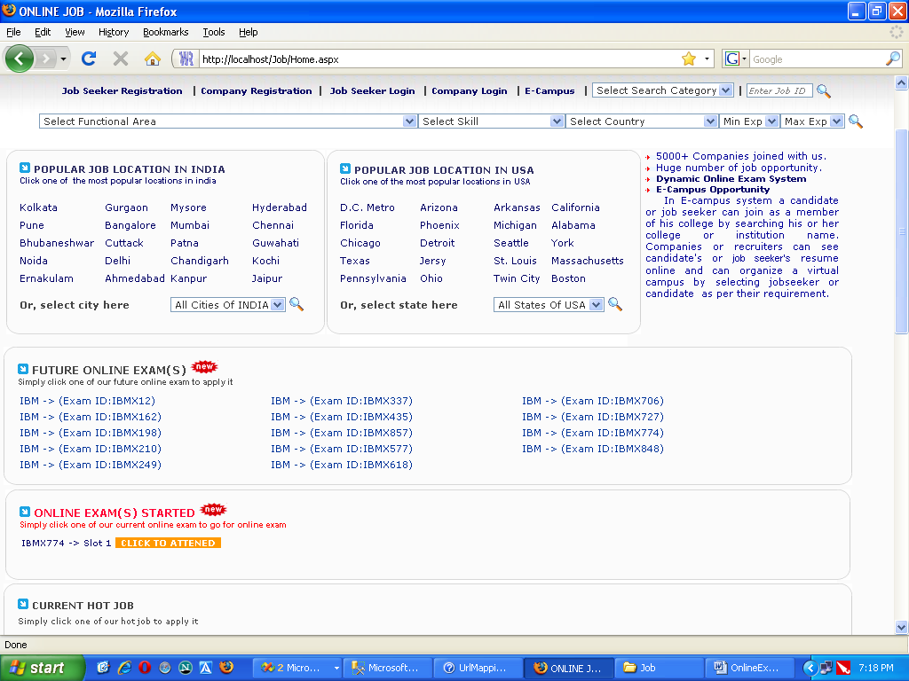
(Figure: 1)

Step 3: Now a login box appears on the screen. Login with your ApplicationID & Password.
(See Figure: 2).

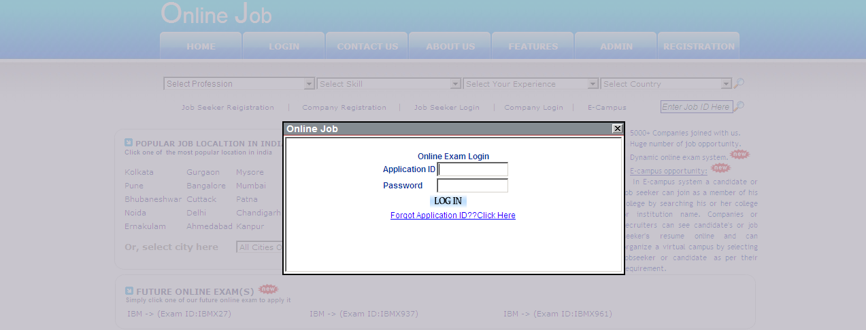
(Figure: 2)

Step 4: A webpage with terms & conditions will appear on the screen. Check the “I Agree the above terms and conditions with best of my knowledge.” Checkbox. Then Click On “Next” Button (See Figure: 3).
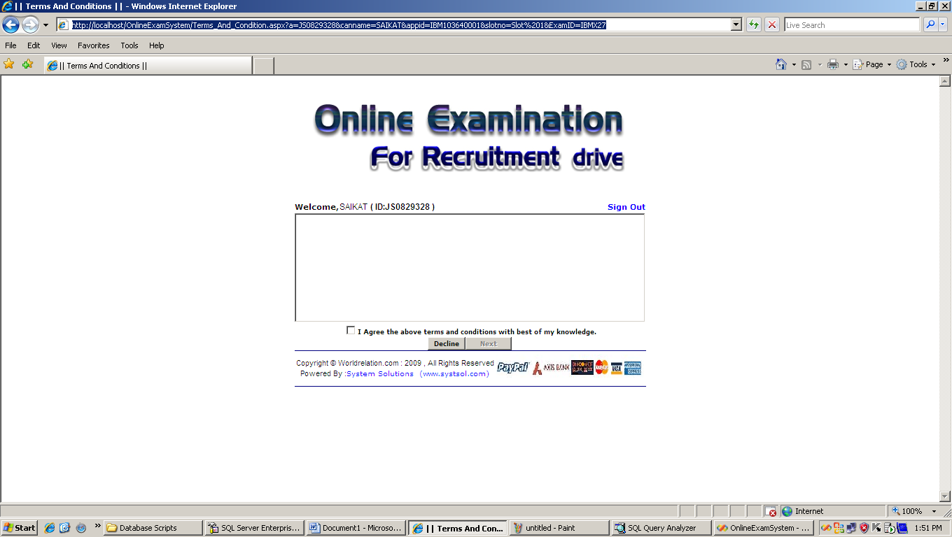
(Figure: 3)

Step 5: Now the webpage appears on the screen where you can give exam. At the end of exam Please click on “Stop Exam” Button. You will see your result. (See Figure: 4)
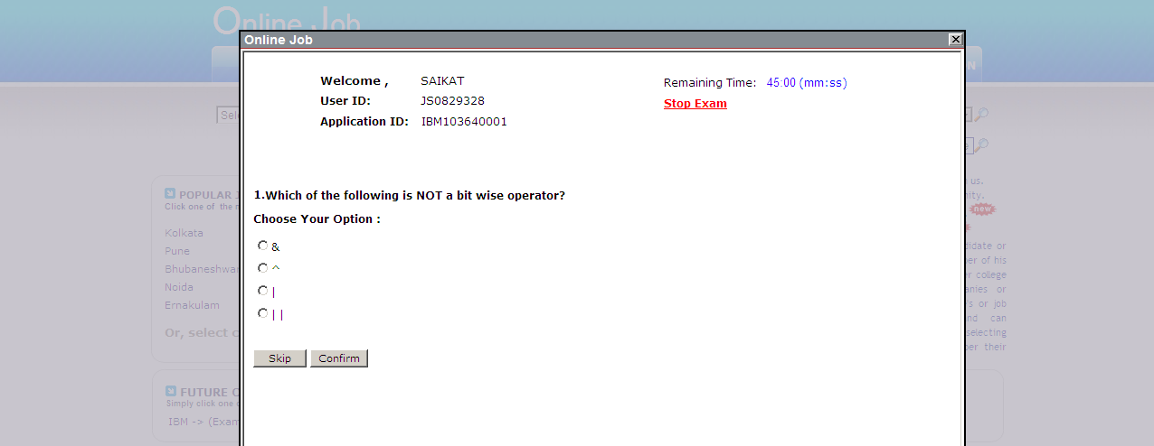

(Figure: 4)

Step 6: Now your exam result will appear on the screen. (Figure: 5)

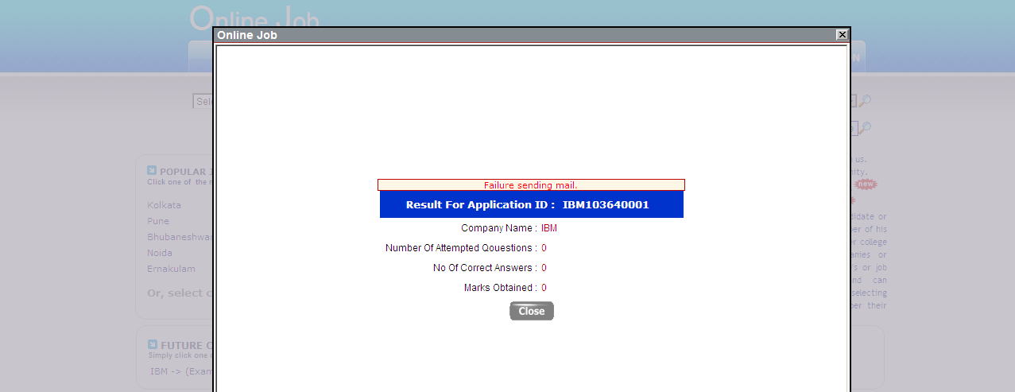
(Figure: 5)

