Step 1: | Go to paypal.com by clicking on “Pay through credit card” link.
Step 2: | Make your payment.
Step 3: | 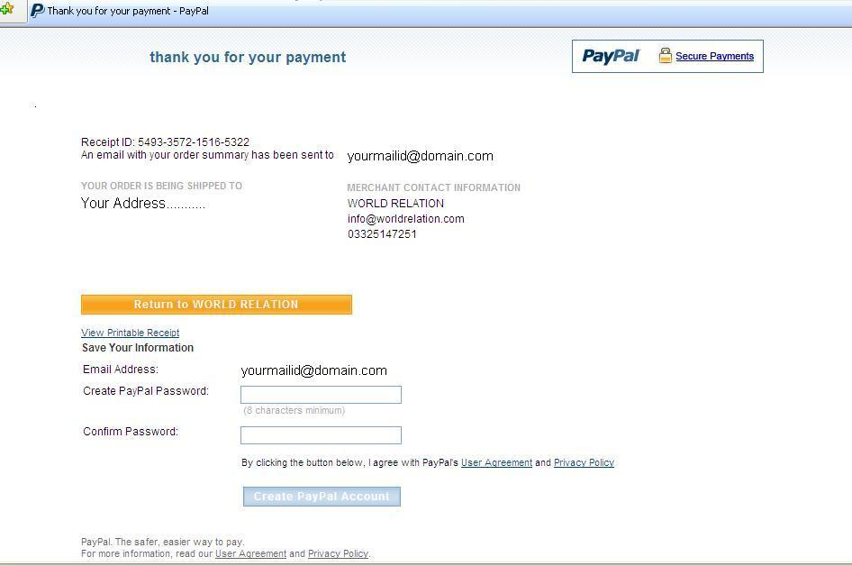  After successful completion of payment process in paypal.com you must click on the arrow indicated button named “Return to WORLD RELATION” for completing the whole transaction. Otherwise the whole payment process remains incomplete.

